Gotrax Electric Scooter
User Guide

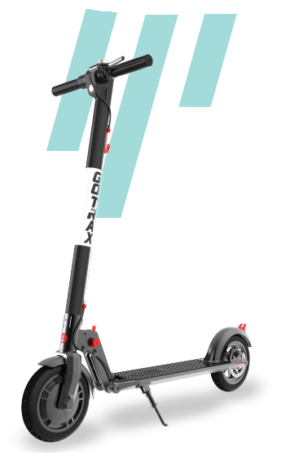
Figure of Gotrax GXL V2 Scooter

By: Isabella Webb

Model: GXL V2

Table of Contents
Gotrax Electric Scooter 1
Overview of Scooter 3
Getting to Know Your Electric Scooter 4
Function of Scooter Parts 4
1. Headlight 4
2. Accelerator 4
3. Console 4
4. Handlebrake 5
5. Charger Port 5
6. Hook 5
7. Tiller 5
8. Folding Mechanism 5
9. Hub Motor 5
10. Fender Buckle 5
11. Kickstand 5
 Battery Information 6
 Charging Your Scooter 6
Folding your GoTrax Electric Scooter 7
Step 1 7
Step 2 7
Step 3 7
 How to Ride Your Scooter 8
• Warnings 9
 Warranty 10
References 11

Overview of Scooter

Top Speed: 15.5 mph
Distance per Charge: 9-12 miles
Weight Range Up To: 220 lbs
Battery Type: 36V 5.2Ah
Battery Charger: DC 42V 1.5A
Charge Time: 4 hours
Power Requirements: AC 100 -240V ~ 50/60Hz 1.8A
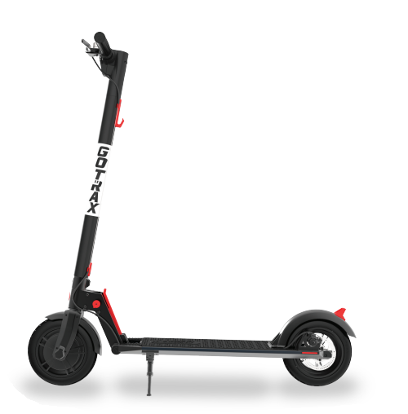
Side profile of GXL V2 Gotrax Electric Scooter

Getting to Know Your Electric Scooter

Function of Scooter Parts

1. Headlight
Press down and release make the dinging sound

2. Accelerator
Used to accelerate. Press down with right thumb after the initial push off with your foot. Take pressure off throttle when wanting to slow down and press down further when wanted to acc

3. Console
Used to power scooter on and off – press and hold red button for 1 second to power on and 5 seconds to power off. Will turn on headlights as well if red button is pressed for 1 second while scooter is powered on.

4. Handlebrake
Press brake towards the handlebars with left hand in order to slow down or stop the scooter’s movement completely.

5. Charger Port
Port to plug in charger for the electric scooter. Scooter should be powered off when charger is plugged into the port.

6. Hook
Used to lock scooter in place when folded.

7. Tiller
Meant to steer scooter. Handlebars are attached to the top of the tiller and the front wheel is attached at the bottom. This allows the user to turn the front wheel by turning the handlebars in the desired direction.

8. Folding Mechanism
When pulling the folding mechanism out, it releases the scooter to fold down towards the back wheel.

9. Hub Motor
When accelerator is pressed down it powers the hub motor and propels the scooter forward.

10. Fender Buckle
The fender buckle is what helps to lock the scooter in place when folded. The fender buckle is what the hook, found near the top of the tiller, latches onto.

11. Kickstand
When scooter is upright and not in movement, the kickstand will allow the scooter to stay upright without the user’s assistance.
12. Disc Brake
The disc brake is used to slow down or stop the scooter all together, by pressing down on the handlebrake on the top left of the scooter’s handlebars.

Battery Information
Only use the approved Gotrax power adapter to charge your scooter, others may cause risk of fire & equipment may be damaged.

Improper disposal of used batteries may seriously pollute the environment. Please comply with local disposal regulations.

Make sure to store your scooter and power adapter in conditions that do not exceed 122 degrees Fahrenheit or below -4 degrees Fahrenheit.

Warning – Risk of Fire – No User Serviceable Parts, The prolonged exposure to UV Rays, Rain and the Elements may damage the enclosed materials, store indoors when not in use.

Charging Your Scooter
- Open rubber charging port cover
- Insert the charging plug into port
- The charger box will have a green light when fully charged and a red light when charging.
- When done charging be sure to cover the charging port with rubber cover to keep it clear of dust and debris
- Charging Time: 4 hours

Folding your GoTrax Electric Scooter

Step 1
Pull red circle attached to the bottom left side of the tiller.

Step 2
While still pulling the red circle out, pull up the red lever in the middle of the connecting piece.

Step 3
The scooter should unlock at this point and begin to fold towards the deck. Guide it down slowly and make sure that the hook at the top of the tiller hooks to the latch at the top of the back wheel.

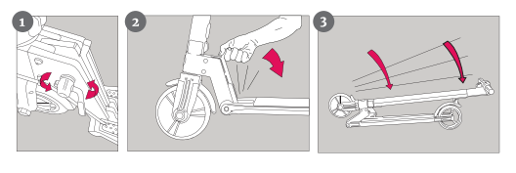
Figure on 3 steps to fold the Electric Scooter

How to Ride Your Scooter
- You will want to start riding your electric scooter with one foot on the platform and one foot on the ground.
- Next, while in this position, you will want to push off with the foot placed on the ground and, at the same time, press down on the accelerator to propel the scooter
- Then to control speed, you can press down on the break on the left side of the handlebars

Warnings
- Avoid Water – The scooter is not waterproof. The electronics may be damaged
- Abuse – We do not cover physical damage due to negligent care and extreme riding
- Injury - Whenever you ride the Gotrax electric scooter, you risk severe injury or even death from loss of control, collisions, and falls. Use caution and ride at your own risk.
- Do not modify the product from the manufacturer’s original design
- Keep hands and all body parts away from moving parts while operating the scooter
- Before riding – be sure to look the scooter over and make sure the scooter is operating correctly before each use.
- The electric scooter should never be used by children under the age of 13
- Maximum Speed – Your electric scooter goes the maximum speed of 15.5 mph.
- Never – exceed the 220 lb maximum load rating

Troubleshooting

We frequently update our user manuals at gotrax.com, and reserve the rights to update and change manuals online.

Please contact our customer service team if you are experiencing problems or need more detailed information. They can be reached at gotrax.com.

Warranty
For warranty information, please visit us at www.gotrax.com


Figure of Gotrax company logo

GOLABS, INC

GOTRAX.com
2201 Luna Rd.
Carrollton, TX 75006

References

- https://cdn.shopify.com/s/files/1/0071/0406/9747/files/G2_Electric_Kick_Scooter_Manual.pdf?v=1684342194

Manual for the Gotrax G2 model electric scooter. Folding is the same process so pictures for folding were taken from this manual instead of the GXL V2 electric scooter

- https://scootertroubleshooting.com/gotrax-g2-plus-common-problems/

Review of the pros and cons of Gotrax electric scooters

- https://cdn.shopify.com/s/files/1/0071/0406/9747/files/Manual_GXLV2_20211215.pdf?v=1652451757

Manual for the Gotrax GXL V2 model electric scooter.

