To: Dr. Jablonski
From: Isabella Webb
Date: September 30th, 2025
RE: Personal Website Plan Draft

Overview
In this document I will be stating, in detail, the goals, content, and design of my personal portfolio website. This means establishing a target audience – who I want to frequent my site – and a purpose – why I want my target audience to frequent my site (what will this accomplish?). In addition, this document outlines the content that I plan to highlight on my site and for what purpose I have chosen that specific content – again keeping the goal in mind. Lastly, this document states the design I have chosen for my site and why.

Purpose
The professional networks that my PLN will be focusing on are communities within the writing/editorial and graduate programs. I would like to pursue a position as an editorial assistant within the publishing industry and/or news outlet. These communities would be comprised of English, Journalism, & Communications students, editorial professionals, and professionals within publishing and press organizations. In addition, graduate program communities will include graduate students, alumni, and faculty groups. My portfolio website’s purpose is to allow employers or recruiters within these groups to view my experience in these fields and evaluate whether I would be a good candidate.

Goals
The goals outlining the focus for my PLN website are as follows:
- To find communities associated with the editorial/writing and graduate program fields.
- To give potential employers and postgraduate admissions a better understanding of who I am and my experience.
- To enhance my understanding of the editorial field through networking.
- To enhance my connections to specific graduate programs.
- To allow for my work to be viewed by professionals in each field.
- To be direct and clear about my academic and career goals.

Target Audience
- Potential publishing employers
- Potential news outlet employers
- Potential technical editing employers
- Graduate programs admissions
- Professionals in the editorial field

Personas
Below are two personas developed with the goals listed above in mind.
Daniel represents the target audience of book publishers. He represents who I would likely be engaging with when pursing a position within a company like this.

Angela represents the masters’ programs target group. When applying for a masters, she will likely be frequenting my site and is who I want to keep in mind when building my site.

Information Architecture
In this section, I will be covering the various parts and pieces – or I should say content – that will make up my personal portfolio website.

Content Inventory
Content shown below is meant to provide site visitors with more information about my work, internship, volunteering, and academic experience. As well as allowing them to get to know me better. I provide photos of myself and links to my social media platforms so that they are able to get in touch with me.
Title | Location | Purpose | Author | Content Type | URL
Introduction | Home Page | Tells users what site is for | Me | Text
About Me | About Page | Provide brief overview of my background | Me | Text
My Photo | About Page | Provides visual of who user is reading about | Me | Photo
Resume | Resume | Highlights work experience | Me | PDF
Technical Writing Sample | Experience | Showcases Tech. Writing Skills | Me | PDF
Top Ten Literature Review Sample | Experience | Showcases writing skills | Me | PDF
Internship | Experience | Provides description of Internship | Me | Text
Link to Internship Website | Experience | Provides more info on company | Roadmap Writers | URL | Roadmap Writers Site
Coverage Writing Sample | Experience | Provides work I did for internship | Me | PDF
LinkedIn | Home Page/Contact | Allows user to see my experience and connect with me | Me | URL | LinkedIn Profile
B2 Certification in French | Resume | Provides level of proficiency in French Language | Université Catholique de Lyon | PDF
Description of French language Experience | Resume | Describes time in France and French studies | Me | Text
Teaching Assistant Overview | Resume | Describes experience as TA | Me | Text
Article about Reading Volunteering | Resume | Provides picture and French description of my volunteering | News outlet in Lyon, France | URL | Article
Description of Reading Volunteer | Resume | Provides English description of work | Me | Text
Email | Contact/ Homepage | Provides work email for getting in touch | Me | Text
Instagram | Contact/ Homepage | Provides social media to get in touch | Me | Instagram User Name

Site Map
This site map outlines the planned layout of my personal portfolio website with navigability and the user in mind.

Backend Site Management
The web-hosting service that I chose is Wordpress.com. I felt that this plan was the best choice for me because, with the amount of time I’ve spent learning about Wordpress, I’ve become more comfortable with the site. I chose the premium plan on Wordpress. I chose this plan because I wanted access to more themes than the standard plan could give me. Furthermore, the premium was only $4 more than the standard, and because I chose 3 years for my subscription, the monthly price went from $8 to $5.50. In addition, the URL I chose was Isabella-webb.com.

Search Engine Optimization
The table below lists some of the keywords that are related to the goal of my portfolio site. Potential employers will hopefully be the ones frequenting the site; therefore, it is important that they have an easy time navigating my portfolio site. More specifically, can they find what they need quickly.
Technical Writing | Bilingual Communication (English/French)
Editing | Content Editing
Proofreading | Literature
Writing | Language
French | English
Teaching Assistant | Content Management
Language Learning | Translation
Style Guide
I would like my language to be professional, as I am hoping to get hired, but I also don’t want to come off like a robot. I want my site to be a tool to help my visitors get to know me better, so the language will be professional and clear but without losing personality. From this, my site visitors will be able to not only get a sense of who I am, as well as the experience and skills that I can bring to the table.

ChatGPT
ChatGPT was used to brainstorm keywords for my site. Below is a link to the conversation I had with ChatGPT. https://chatgpt.com/share/68cc1cf6-69b8-8008-bb1a-c18e7fa7fe8b

Theme Choice
The name of my Wordpress theme is Gourmetto. I found it listed under the Blog section of Wordpress themes. I chose this theme because I thought it seemed easy to navigate. I wanted my homepage to show the navigation tools clearly so that the user doesn’t spend more time than necessary looking for things like my resume or experience. Furthermore, I chose this theme because it has a search bar – keeping in mind that many users are search dominant.
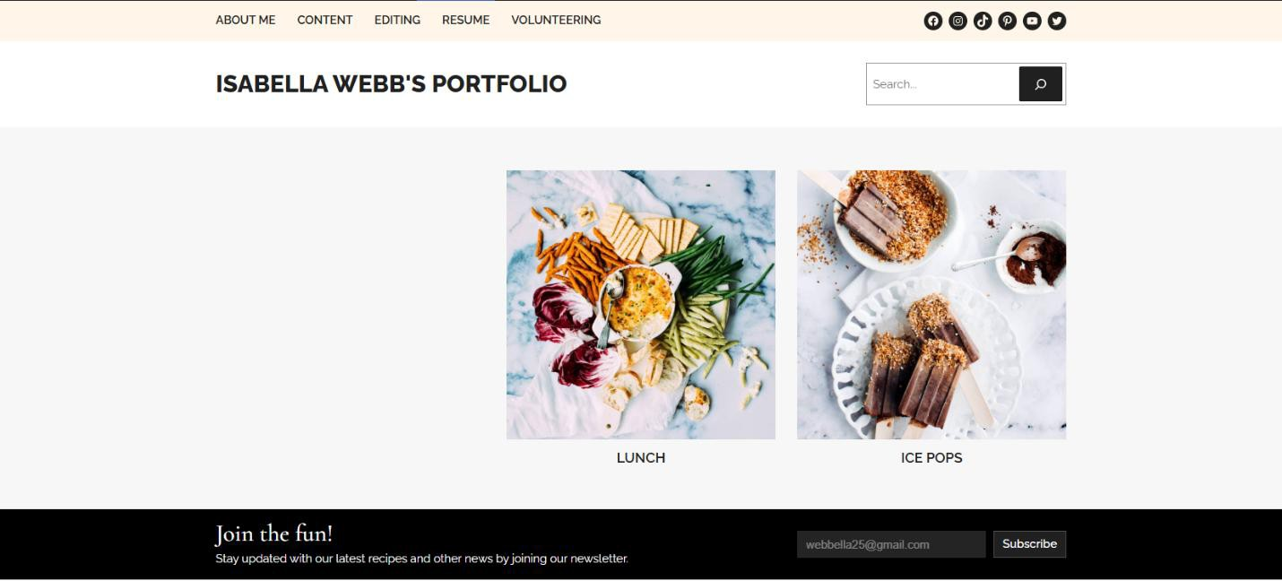

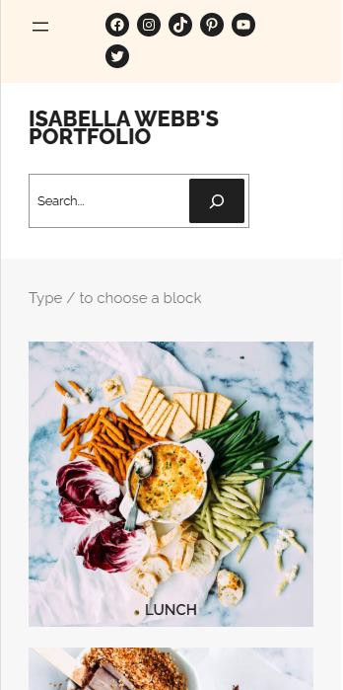
Responsiveness
In addition, this site is responsive to mobile devices. When viewing on a mobile device, the navigation bar collapses into two lines (typically referred to as “hamburger button”) on the top left of the homepage.
Meanwhile, the homepage content, title, search bar, and socials are still clearly visible

Page Design
Theme meets following interface/page design criteria listed in “Word Style Guide”:
- The header, navigation, submenus, and breadcrumb trails are clear
- Theme contains search bar.
- Hyperlinks are clearly visible (and those that aren’t can be edited to become so)
- The header and search bar can be seen on every page so that viewer is never led to a dead-end

Elements | Home Page | Pathway Pages | Content Pages
Static Link to Home Page | X | X | X
Page Title and Headlines | X | X | X
Informative HTML page title | X | X | X
Global Navigation Links | X | X | X
Social Media Logo Links | X | X | X
Stie Logo w/Link to Home |  | X | X
Link to Local Home/Menu Page | X | X | X
Breadcrumb Trail Navigation
Search Form at Top Right | X | X | X
Primary Page Content | X | X | X
Sub menu for local content | X | X | X
Recent Posts | X | X | X
Copyright Statements
Contact Information Footer | X | X | X
Creation or Revision Date
Alt Text Identifying Graphics | X | X | X

Universal Design
Accessibility is achieved through the following aspects of my site.
- Color is accessible through the use of colors with sufficient contrast.
- Space will be accessible through the use of grids where content is aligned. Furthermore, headings are not floating.
- The font “Poppins” has been installed so that font is legible and sans serif. Only link on site at the moment is to an article about my volunteering in France – this shows up as an embedded URL.
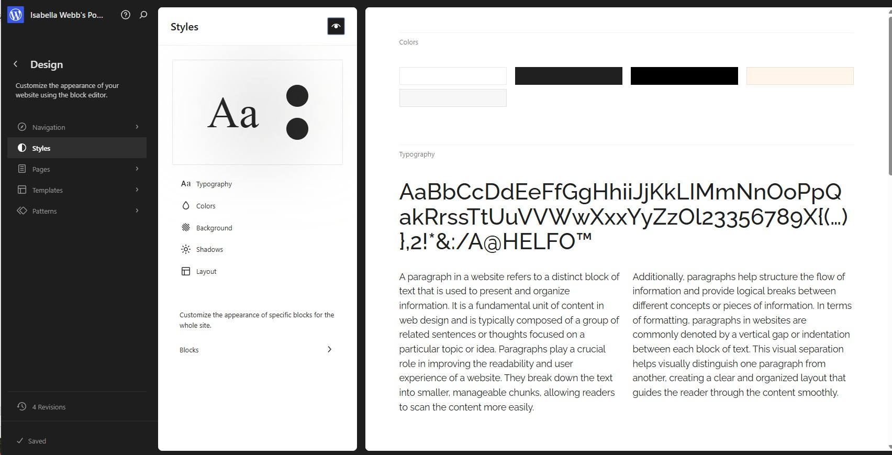

Conclusion
For my personal portfolio website, I will be utilizing all topics above in its’ creation. This means that I will be developing my site with the plan and knowledge in this document in mind. I will be keeping my goals and target audience at the forefront of my planning – making sure that I am establishing a portfolio website that is not only accessible, search engine optimized (SEO), and user-friendly, but a site that is tailored for the targeted audience.

